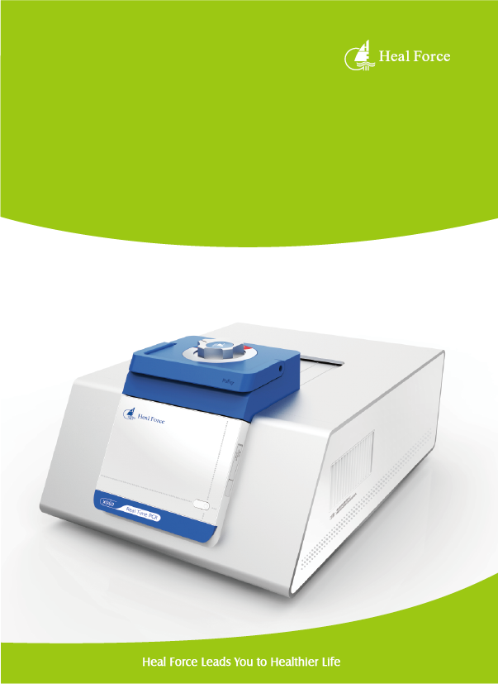
Life Science

Heal Force Real-Time PCR
A platform you can depend on

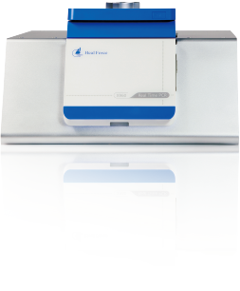

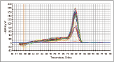
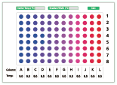
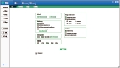
Humanization Design
Advanced programming function like gradient and touch-down
The machine can be connected with Pc through WI-Fl or LAN
Software allows you to manage and monitor several x960s from your computer
Low noise, low energy consumption, long life-span
Product Introduction
The X960 Real-Time PCR system is a high-performance benchtop instrument giving you greater control of your experiment data. It delivers reliability, sensitivity, and accuracy, which is optimized to enable the broadest range of quantitative PCR applications
In real-time quantitative PCR(qPCR), PCR product is measured at each cycle. By monitoring reactions during the exponential amplification phase of the reaction, users can determine the initial quantity of the target with great precision without involving post-PCR analysis such as gel electrophoresis and image analysis
Precise Temperature Control
Block utilizes most advanced Peltier-based technology with high amplification efficiency
Up to 6 C/s maximum ramp rate saves your valuable time dramatically
Two independent temperature control mode- block and tube, maximize control flexibility
Excellent temperature uniformity limits the variation between wells, ensuring the accuracy of low copy sample

Innovative Optical Design
Two channel(X960A)and five channel(X960B)fluorescent detection system with
LED light source and high resolution CCD
The optical system automatically collects data from all wells during data acquisition at the same time
X960 can discriminate up to five targets in a single reaction well
The optical filter sets are designed to maximize fluorescence detection for specific dyes in specific channels
Compatible with different reagent and consumables

Ready to Run
Factory calibrated for optical and thermal accuracy, the instrument is delivered ready for quick installation and use
Powerful Software
X960 Manager Software accommodates individual needs with intuitive navigation and customizable settings
The software can be used for a variety of applications including absolute/relative quantification, melting curve( dissociation curve),etc
With integrated powerful visualization tools, the data is analyzed on machine directly
X960 Real-Time
PCR Systems

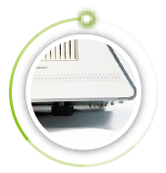
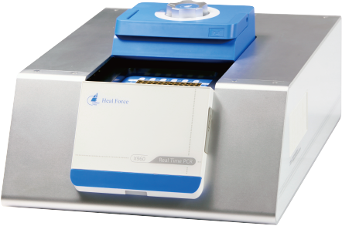
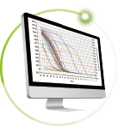
Lid
3D style design with well pressure distribution and heat preservation
Unique sliding track is convenient for sample operation
Robust construction
6mm aluminium alloy main body with solid construction, nice looking curves
and fresh color
Adjustable footing designed for
achieving balance easily

Software
Independent software analysis module
Intuitive software design enables easy experiment setup and an interactive system allows you to get results faste

Operation system
Developed upon Linux operation system, and equipped with A8 CPU for better control experience

Blocks
Compatible with 96-well plate, 12-well strip tubes, 8-wel strip tubes
High quality peltier plates ensure amplification efficiency
Standard gold-plating promotes heat conduction performance
Model  Technical specifications | X960A | X960B
Channel | 2 | 5
Reactions per run | 96 | 96
Block Format | 96-well 0.2-ml | 96-well 0.2-ml
Color Combinations | Up to 2 | Up to 5
Light source | High brightness monochrome LED | High brightness monochrome LED
Detector | Highly sensitive ∞ld light CCD | Highly sensitive cold light CCD
Detection dynamic range | 10²-10¹° | 10²-10¹°
Sensitivity | Down to 1 ∞py | Down to 1 copy
Reaction volume | 15ul-100ul | 15ul-100ul
Chemistry | All real-time PCR-based chemistries. Flexibility for chemistries with or without passive reference dye.
Excitation source | White LED | White LED
Excitation filters∕∞lors | Channell: 470nm Channel: 525nm | Channell: 470πm Channel: 525nm
 | - | Channels： 585 nm Channel4: 625nm
Detection filters/colors | Channell: 520 nm Channel: 570 πm | Channell: 520 nm Channel: 570 nm
 | - | Channels： 620 nm Channel4： 675 nm
Kits & Reagent | Channell: FAM/SYBR | Channell: FAM/SYBR
 | Channel: VIC/HEX/JOE/TET/TAMRA | Channel: VIC∕HEX∕JOE∕TETΠAMRA
 | - | Channels： ROXfΓEXRAD
 | - | Channel4: CY5
Block Material | Peltier | Peltier
Accuracy | ±0.ΓC | ±0.ΓC
Temp Uniformity | ±0.4 C (10 sec after reaching 95 C) | ±0.4C(10 sec after reaching 95C)
 | ±0.2 C (10 sec after reaching 55 C) | ±0.2 C (10 sec after reaching 55 C)
Temp Range | 0'C-100'C | 0C-100C
Max. ramp rate | 6C | 6C
Gradient range | 30C-100C | 30,C-100C
PC Operation system | WindowsXP∕VISTA∕Windows7∕Window8 | WindowsXP∕VISTA∕Windows7∕Window8
X960 Operation system | linus | linus
CPU | A8 | A8
Network | LAN /WIFI | LAN /WIFI
Multiple control | Support | Support
Applications Available | Gene Expression, Genotyping, Copy Number ∖^riation, Protein Detection, MicroRNA, Pathogen Detection
Size | W 592 ×D 440 × H 280 mm | W 592 × D 440 × H 280 mm

Heal Force Bio-Meditech Holdings Group

Heal Force International Trading（shanghai）Co.Ltd
6788 songze Road，Qinpu District，shanghai201706，P.R.China
Tel： +86 21 62728646 E-mail：export@healforce.com
Fax： +86 21 62710529
Website： www.healforce.com
Information is subject to change and/or updating without notice. Copyright © 2015 Heal Force. All Rights Reserved.

