Life Science
Heal Force

OptiClean 900/1300
Vertical Laminar Flow Clean Benches
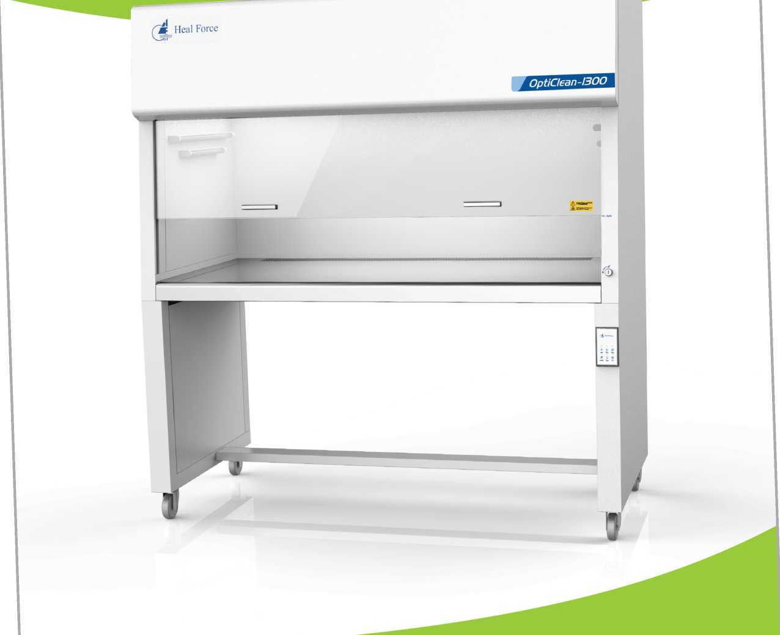
Heal Force Leads You to Healthier Life
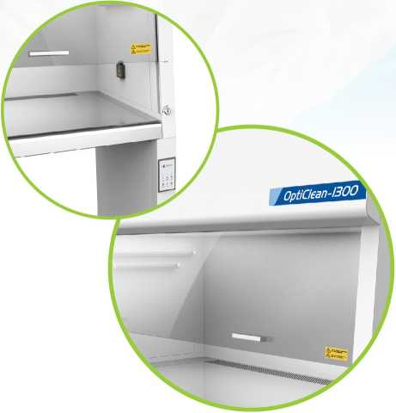
www.healforce.com

Enhanced comfort and convenience
5 ° backward-slanted safety grade glass provides more comfortable viewing
Long life HEPA filter offers high separability for particles with high uniformity of air flow
Counterbalanced sliding sash is designed for easy operation with single hand.
Multiple levels of air flow speed are standard configured for wide range of applications
Universal wheels are designed for easy transportation
Advanced door lock guarantees your sample security to prevent unauthorized access
 | OptiClean900 | OptiClean1300
Cleanliness in Work Area | ISO Class5, Class 100 (Fed 209E)
Prefilter | High efficiency polyester fibre
Main Supply Filter | HEPA with 99.99% Separability at 0.3um particle size
Veritical Airflow Velocity | 0.30 ~ | 0.60m/s(Adjustable)
Noise Emission | <65 dB(A) | <65 dB(A)
Fluorescent Light Intensity | >300 Lux | >300 Lux
Nominal Power | 300 VA | 550 VA
RMS | <5 um | <5 um
External Dimensions (WxDxH) | 1050x730 xl640mm | 1500x730x1640 mm
Internal Dimensions (WxDxH) | 950 x 650x510 mm | 1400x650 x 510 mm
Operator No. | One side for one person | One side for two persons
Net Weight | 110 Kg | 140 Kg
General Specifications, OptiClean Vertical Laminar Flow Clean Bench
Heal Force Bio-Meditech Holdings Group
Heal Force International Trading(Shanghai) Co., Ltd
6788 Songze Road, Qingpu District, Shanghai 201706, P.R. China
Tel +86 21 62728646 Email export@healforce.com, Fax +86 21 62728646

Information is subject to change and/or updating without notice © 2020 Heal Force. For internal use only

