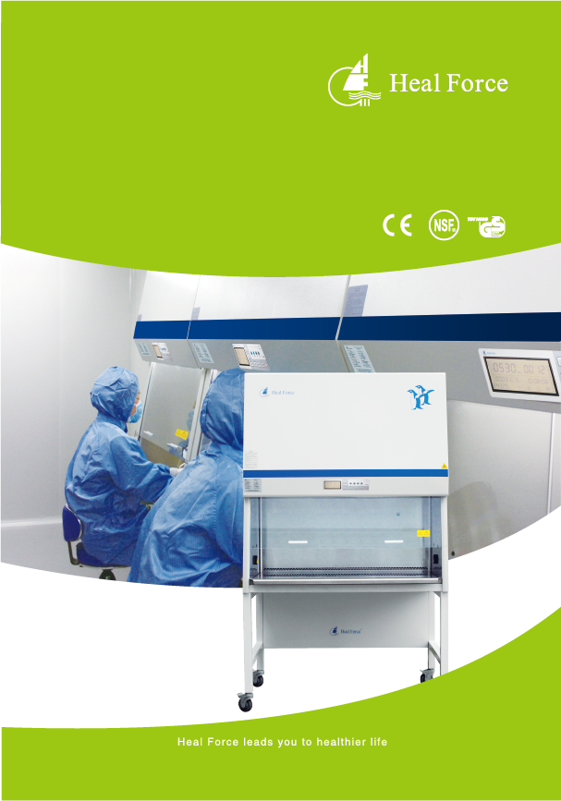
HFSafe LC Series
Biological Safety Cabinet

The next level of

performance

HFsafe LC
Biosafety Cabinet

Product and Solution Overview

Heal Force HFsafe LC biosafety cabinets set the standard in quality design, and innovation that comes from a heritage of over 25 years experience. At Heal Force we know how important it is to offer a high level of protection to operator, sample and environment with advanced technology. With an extensive track record of safety, reliability and performance, HFsafe LC cabinets make ideal investments for a wide range of applications including work with infectious agents that require Biosafety Level 1, 2 or 3

Biological Safety Cabinets

Table of Contents

What to look for
in an ideal BSC?
Which
system
is best
for you?

Global market vision
and design philosophy

Heal Force Solution

11 Options and Accessories

15 LCA2 technical specifications

17 LCB2 technical specifications
6 Advanced design for non-compromising safety

7 Enhanced comfort and convenience

8 Easy to clean and outstanding decontamination
9 How to set a new benchmark for the whole industry?

13 Service Access and Validation

14 Standard and Test

What to look for

in an ideal BSC?

Proven Reliability
Outstanding safety is assured through avariety of core components and features to improve cleanliness and eliminate sample contamination risk.
Energy Efficiency
From the motor controller to the lighting,new patent-pending innovations provide significant annual cost savings while maintaining superior performance.
Outstanding Comfort
With seven thoughtful features, from the view screen to the work environment and ergonomic design.
Added Conveniences
Packed with convenient features and the largest,unobstructed usable work area in the industry, there, s plenty of room for lab equipment and less hassle when managing controls.
Easy to Clean
An exceptionally reliable membrane-sealed control panel, and a one-piece work surface featuring radius ed, caved corners instead of seams, allows for easy and effective cleaning
Certified Performance
With an innovative front-access design, on-site validation, customer support packages,
Maintenance is quicker and easier

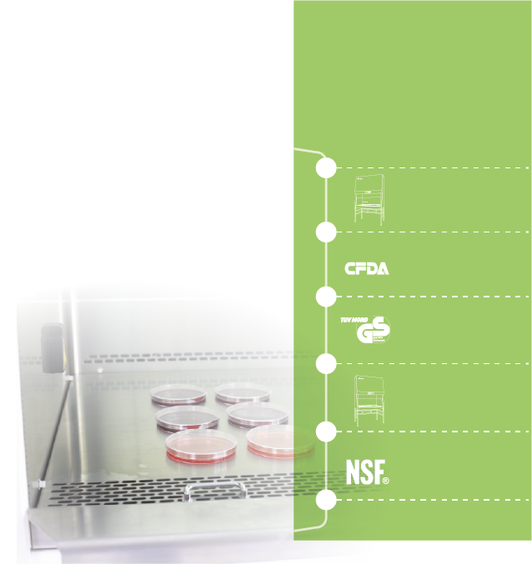

Innovation TIMELINE
Heal Force HF safe LC biosafety cabinets set the standard in quality, design, and innovation that comes from a heritage of over 25 years* experience. With an extensive track record of safety, reliability and performance, HFsafeLC cabinets make ideal investment for a wide range of applications.

1999
Our first product line of
safety cabinet

2005
One of drafters for YYO569 standard formulation in China

2007
The first in Asia got stringent certificate of TUV-NorCBGVEN12469

2013
Launch of the energy efficient HFsafeLC series A2 BSC

2014
HFsafe LC series are tested and certified to
NSF∕ANSI49

Heal Force

Which System is best for you?

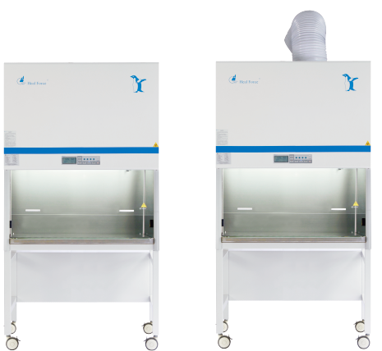

Class II | TypeA2 | Type B2

 | Medium Preparation | o | o
 | Tissue Culture | o | o
Biotechnology | Blood Elements Analysis | o | o
 | Human Histology | o | o
 | Polymerize Chain Reaction | o | o
 | Medium Preparation | o | o
 | Culture nuisance odors | - | o
 | Isolated Clinical Sample | o | o
Microbiology | Blood 7est∕Analysis | o | o
 | QA/QC | o | o
 | Minute Quantities of Volatile Toxic Chemicals |  | o
 | Trace Amount of Radiotelephones |  | o
Pharmaceutical | Anti tumor drug preparation |  | o
 | Trace Amount of Radiotelephones |  | o
Routine research | Cell/Tissue Immobilization & Staining |  | o
 | Toxic Powder/ Suspended Substance | o | o

HFsafe LC Type A2 HFsafe LC Type B2

With a range of biological safety cabinets, Heal Force has the right technology to
meet every application, setting, and budget.
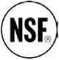
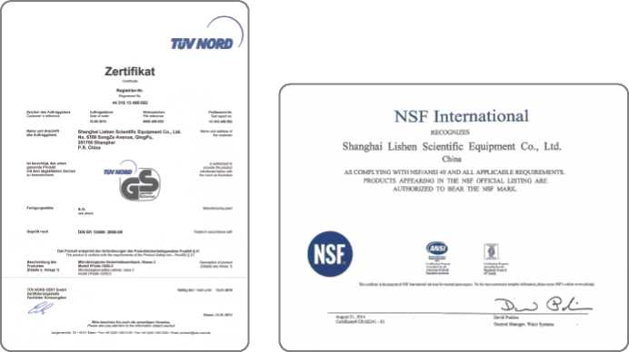
YY0569
Heal Force, as a leading dafter for Chinese BSC standard, has HFsafeLC series independently tested and certified to YY0569

EN12469
Our Class II type A2 biological safety cabinets are independently tested and certified to EN 12469 standard by TUV Nord, a leading testing agency in Europe

NSF/ANSI 49
HFsafeLC series are independently tested and certified to NSF/ANSI 49, By NSF International, a leading testing agency in the USA.

Global market vision

At Heal Force we know how important to design a product in compliance with current worldwide safety standards. There are three widely recognized global standards for BSC performance: NSF/ANSI 49 (American Standard), EN 12469:2000 (European Standard), YY0569:2005 (Chinese Standard).
Save energy, maintains sterility
When the front sash is closed, our intelligent speed control automatically reduces flow speed Less air flows through the ULPA filters, extending filter life and decreasing energy consumption.
Continuous airflow helps to maintain a sterile working environment, even when the cabinet is notin use
Hy-ChamBer plenum design with long life and lasting containment surrounds contaminated areas Negative-pressure, dual side walls prevent the possibility of contamination from leaks to the exterior environment
Flow-safe technology is designed to ensure your safety. Laminar airflow over the working area takes containment to new levels
Smart and self-induced motor monitors and controls fan speed in real time to maintain constant airflow during filter loading or temporary obstruction.
Antedate Flow-safe system automatically balances the downflow and inflow velocities to maintain user and sample protection
Uniform, non-turbulent air stream protects against cross contamination within the work area
Complete your operation requirements with Heal Force Lab-alert monitoring solution. Lab-alert > makes the monitoring of your biosafety cabinet easier than ever. You can keep a constant check on the airflow, window position etc.- anytime, anywhere.
Monitoring system alerts user when containment is compromised
Dependant sensors detect airflow changes constantly to ensure safe operating conditions.
Airflow velocities are displayed on the control panel for monitoring and recording.
Visual and acoustic alarm for indication of unsafe airflow conditions and window position
A sash position indicator decal provides a visual confirmation of the proper working height
Behind the primary function to provide you cleanliness and containment, there, s the technology that made it all possible. Heal Force Flow-safe, Lab-alert, Low-Vel are innovations designed to increase safety and minimize sample contamination
Behind every great discovery, there is the technology that made it all possible.

Non-compromising safety

Enhanced comfort

and convenience

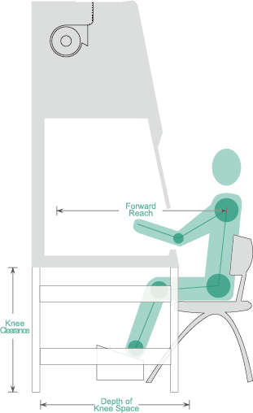
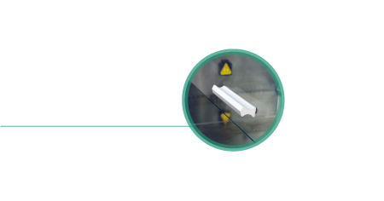
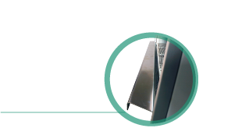
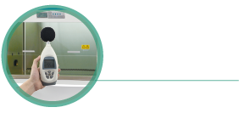
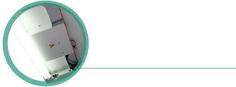
The radius ed edge prevents the potentially dangerous practice of placing materials in this area
The position of the light tubes ensure excellent illumination over the whole working zone and reduces operator fatigue comfortable viewing than vertical sashes.
10 0 backward-slanted safety grade glass provides
protection from explosion and UV with more comfortable
viewing than vertical sashes.
The position of the light tubes ensure excellent illumination over the whole working zone and reduces operator fatigue comfortable viewing than vertical sashes.
Counterbalanced sliding sash can be raised to a maximum height for easy introduction of large itemsmore comfortable
viewing than vertical sashes.

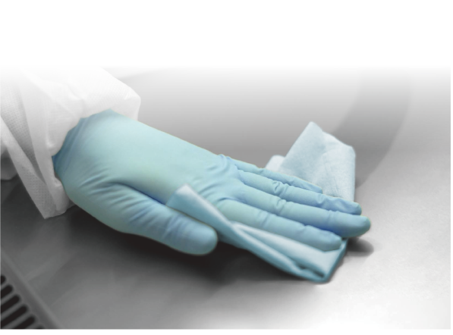
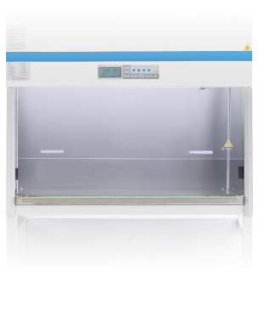

Easy to Clean

Programmable automatic UV light timer simplifies operation while extending UV lamp life and saving energy.
Powerful UV irradiation illuminates entire work area, design to ensure thorough disinfection of the complete chamber
UV lamp with interlocking safety switch allowing operation only when blower and fluorescent light are off and sash is fully closed
Unique hidden UV lamp protects operator1 s eyes from hurt
The cabinet work zone has no welded joints to collect contaminants or rust.
Details of cabinet developed further to ensure easier cleaning with normal cleaning solvents
Airflow lamina tor protects the filter surface during wipe cleaning.
Optional multiple piece stainless steel work surface is easier to remove and put into autoclave / washer.
Bottom sink is made of stainless steel type 304 with round corners and draining valves

UV Decontamination

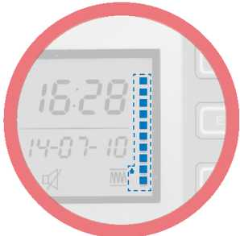
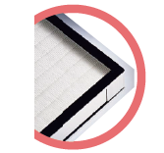
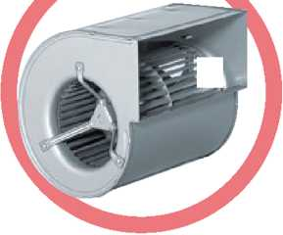
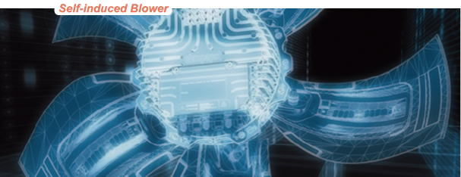

How to set a new bench

ark for the whole industry?

Filter Life indication

Filters has estimated service life, which is uncertain subject to different local air quality
research subjects and operation frequency.
There is potential pollution hazard if operator is unconscious to filter expiration
Patented filter life indicator is designed to measure filter life according to actual
condition of membrane
You can rely on filter life indicator to make a confident plan for future filter replacement
HFsafe LC biosafety cabinets are equipped with long life UL Pa filtration technology by Swedish Camfil Farr
Supply and exhaust filters provide 99. 999% typical efficiency for particle size of 0. 1 to 0.2 microns, providing superior product protection over conventional HEPA filters.
Silicate glass fiber treated with moisture-proof hydrophobic bonding agent is folded in
aluminum alloy frame to enlarge filtration area
Leak-free performance is guaranteed through structural stability and scan test conducted
Self-compensation for the clogging of filters optimizes filter use and minimizes service
ULPA Filtration System
German made ebm-papst motors selected for energy efficiency, impact design, and flat profile. Synchronously mmunicates with microprocessor, there is no need for manual speed ntrol Automatically mpensates for normal power line variation, air disruption and filter loading. Motor nsumes less energy, reduces heat output and operates more quietly
Airflow velocity monitoring
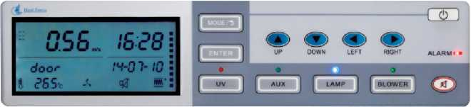
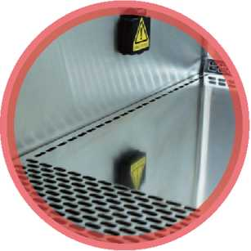
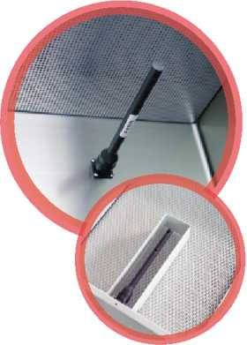
Exaust airflow sensor
Temperature-compensated airflow sensors monitor the airflow constantly to ensure safe operating cond itions are maintained
Two independent sensors(downflow exhaust airflow)mean double security.
Downflow sensor provides instant and precise feedback to the blower so that its speed remains constant regardless of changes in conditions, such as filter loading
Velocities of airflow and temperature are inspected at real-time, and indicated on the control panel
Alarm thresholds(±10% of the control point are precisely controlled via microprocessor which guarantees excellent airflow performance

Friendly Communication
The durable LCD is mounted at eye level for
at-a-glance viewing of airflow, operating
parameters, and alarm messages.
The intuitive interface delivers a constant
read-out of working area temperature, air veloaity'volume, flter Ife span, total running time
Easy-to-clean touchpad controls allow manual activation of blower, lamp, UV, electrical receptacles
Engage the security lock feature to prevent access to the cabinet by unauthorized or unfamiliar user

Robust Construction Compact Design
Energy saving epoxy/polyester coated steel exterior with solid construction, nice looking curves and fresh colour
Constructed of seamless, non-porous, autoclavable Type 304 stainless steel for working plate, one-piece side/rear walls and bottom sink
Slim, compact design and dimensions allows for easy positioning and location in the laboratory, can be easily transported through standard 800 mm doorways
The low cabinet height allows the choice of bench top location or mounting on a support stand, easily accommodated in a laboratory with 2. 5m ceiling height
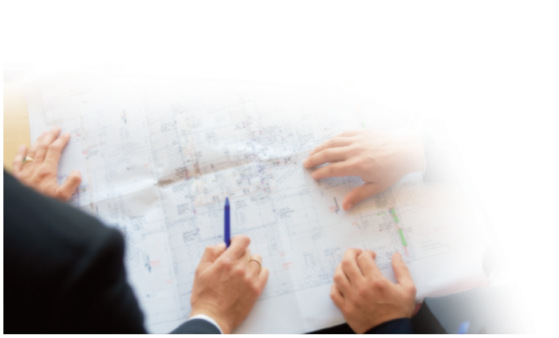
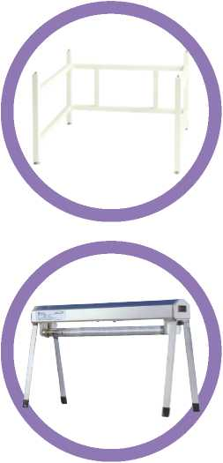
Contact Heal Force for ordering information and technical assistance in selecting the right duct work for your installation
Prefilters

Optional prefilters can be located beneath the work surface, prevents wipes from being drawn into the blower where they could damage components and alter airflow
Ultraviolet Lamp Kits
Controlled by automatic UV lamp timer through microprocessor control panel
Emission of 253. 7 nanometers for most efficient decontamination
Lamp is positioned away from operator line of sight for safety and proper
exposure to interior surfaces
Optional mobile UV lamps strengthen the decontamination effect

Support stand

Options and Accessories

Saves lab bench space and ensure stability & ergonomic working position Standard heights available: 560mm (22.0"), 660mm (34.0") or 760mm (29.9,,) Manual adjustable leveling feet to mpensate for ground unevenness.
Available with castors (option) for easy re-location or transportation.
Durable polyurethane caster wheels with 360 degree horizontal rotation
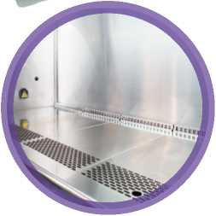
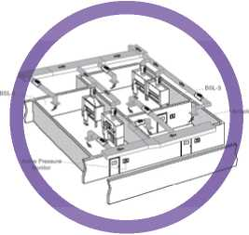
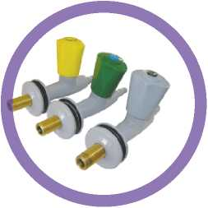
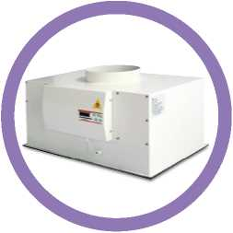
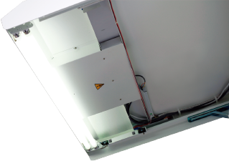
Others
Two electrical duplex receptacles, with ground fault interruption and splash covers
Service valves for Gas. Water and vacuum mounted on side wall.
PVC Armrest Chemically treated, improves operator comfort, easy to clean
Foot pedal for front window control
Loop heat sterilizer
If biosafety cabinets are used for minute quantities of volatile toxic chemicals and trace amounts of radiotelephones required as an adjunct to microbiological research, they must be exhausted through properly functioning exhaust canopies The extraction of exhaust air from HFsafe LC cabinet is usually achieved by either a dedicated or"shared"extract duct, in either case it is always via an electric closed exhaust valve& constant flow rate valve with a coordinated control system.
Exhaust connection fitting
Disposable, impregnated carbon filters(AAF)trap non-volatile nuisance odors of chemicals in the exhaust airflow
Mount atop the biosafety cabinet
Independent display panel for pressure, temperature, working time of filtration system
Coordinated control with biosafety cabinet, which can adjust the exhaust airi volume automatically to minimize filter load variation effect.
Real-time filter life display with a visual and audio reminder

Active Carbon Postfilters
The polished, standard stainless steel Multi-purpose table top
is easy to remove for cleaning
This flexibility of work top choice enables the HFsafe LC to be configured to suit your exact practical requirements
Other options are available to suit customer requirements
Illumination light provides sufficient brightness to the working chamber. There are two illumination lamps located at inner side of the front panel
Illumination Light
Worktop
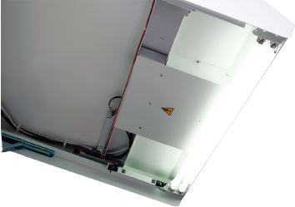
Heal Force offers a wide range of high quality services for all our equipment. These services include on-site validation, customer support packages, factory acceptance testing.
Choose Heal Force as an equipment supplier and validation nsultant can greatly reduce the time and cost involved with getting new equipment compliant and ready for use.
Validation
Unique services Heal Force Offers:
On-site consultation
Unit specific authorized proto documents
Customizable testing procedures to meet customer specific requirements
Unbiased testing of competitive equipment
Pre-delivery Services:
Validation support
Consultation
Factory acceptance testing
On-site Services:
Installation qualification
Operational qualification
Calibration
Change of HEPA filters
Fluorescent lamps
UV lamps
Adjustment or change of circuit boards and sensors
All adjustments to alarms, fan speed, and DOP valves are made via the microprocessor control panel
Service code protected

Help for rectifiers, the hinged maintenance assembly opens to a fixed position on integrated, gas spring struts providing front service access. Consequently, the cabinet can remain in situ without making any positional changes in your laboratory or having to disconnect any ducting
All service is performed from the front of the cabinet, including:
Service Accessv
All services, adjustments and filter change is carried out
from the front of the cabinet.

Service Access

& Validation
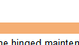
Standards Compliance
Standards & Test
Biosafety Cabinets | EN12469f Europe, Certified by TUV NORD / NSF^19,USA / SFDA YY0569j China / SANS 12469, South Africa
Air Quality | ISO 14644.1, Class 3j Worldwide
Filtration | EN-1822(H14). Europe ∕ IEST-PR-CC001.3. Worldwide / IEST-PR-CC007.1. Woridwide / IEST-PR-CC034.1. Worldwide
Electrical Safety | EN61010-1 _{r} Europe / IEC61010-1 _{f} Worldwide / CSA C22.2 No. 61010-1-121UL 61010-1:
Manufacturer Qualification | ISO 13485:2003, Certified by TUV SUD / ISO 9001:2008, Certified by TUV SUD
Comprehensive performance testing
Every HFsafe model manufactured by Heal Force is individually tested, documented by serial number and validated with the following test methods

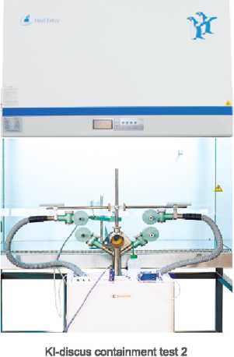
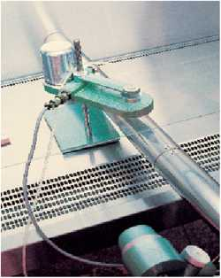
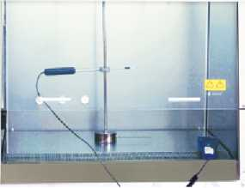
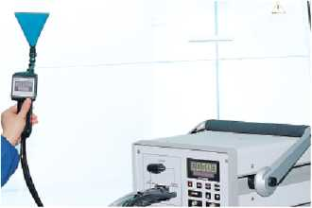
KI-discus containment test 2
KI-discus containment test 1
KI Discus Containment Test According to EN12469(Potassium lodide)
Heal Force is currently one of the few companies in the world equipped to
perform the KI Discus test for validating the operator/personnel protection
capabilities of biosafety cabinet
The KI Discus test shows excellent correlation
with the microbiological test method for
operator protection, and is useful for validating
the actual containment performance of the
cabinet on-site
The Kl-Discus takes only 45 minutes as
opposed to 2 days for microbiological testing
Thus, Each HFsafe model is factory tested on
a sampling basis using the KI-Discus method
for operator safety.

scan test for filters Vibration test lumination test

Inflow/downflow velocity Air particle count test UV radiation test

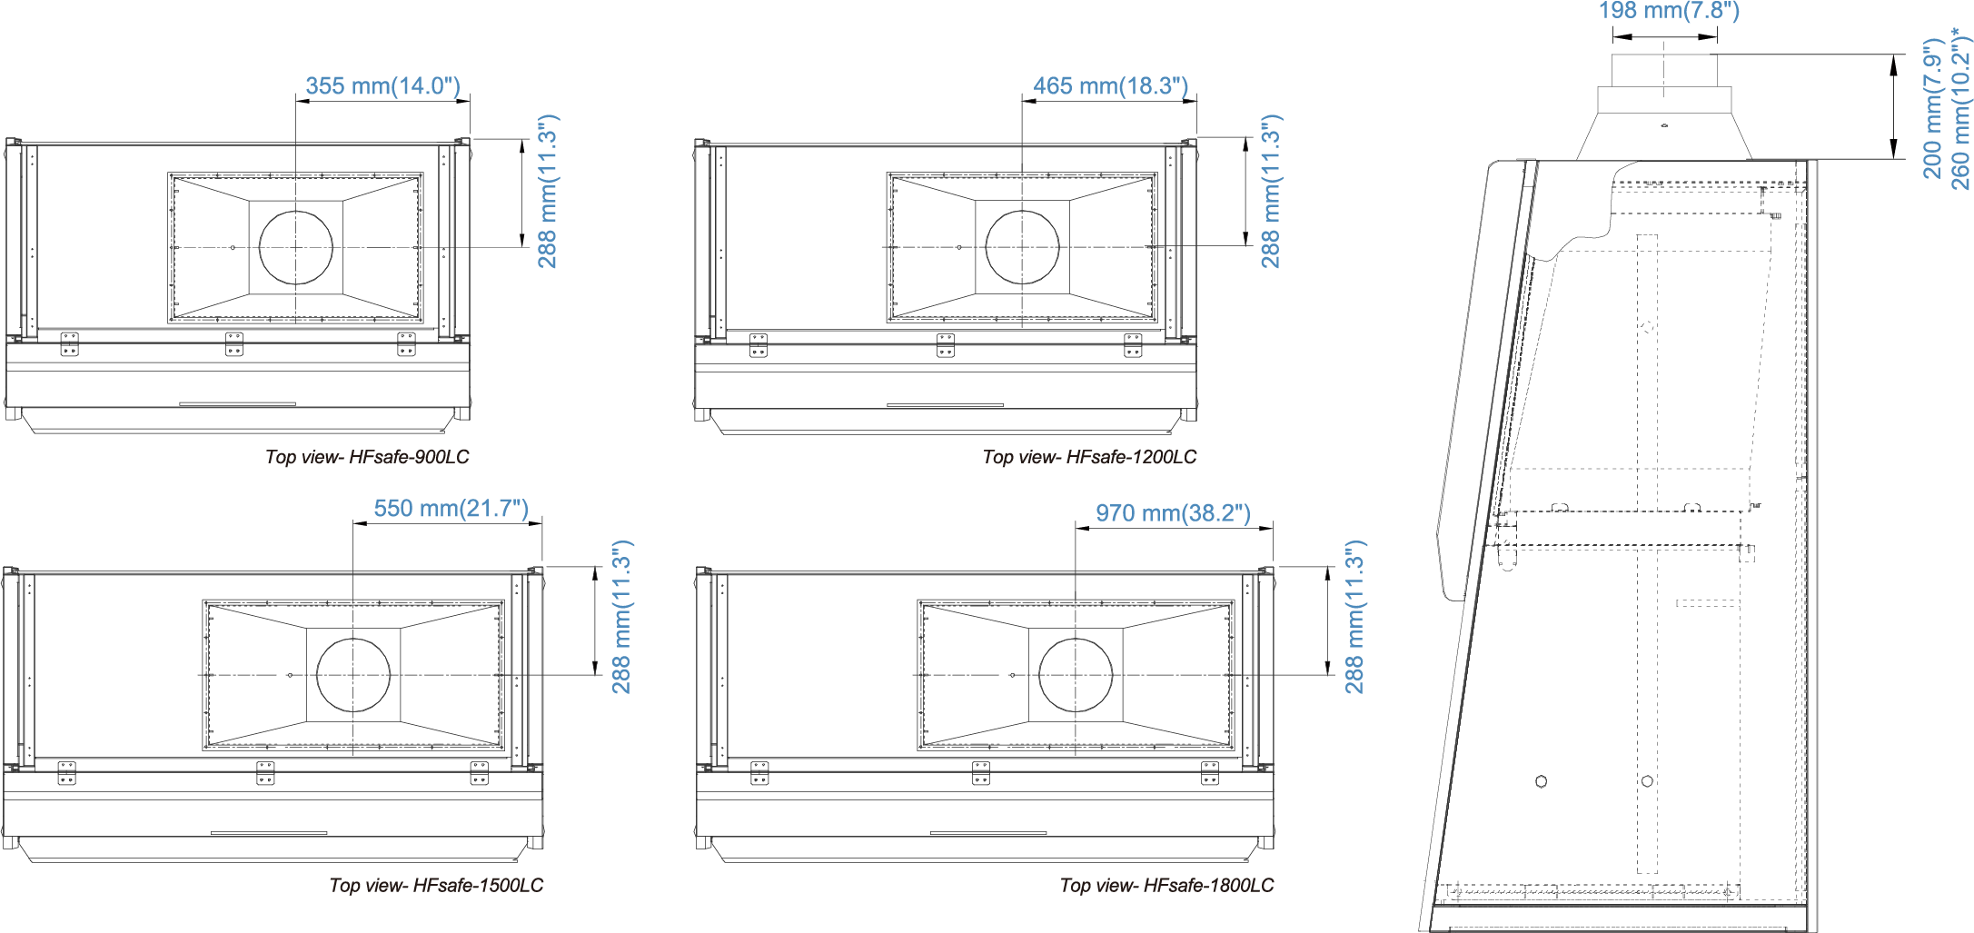
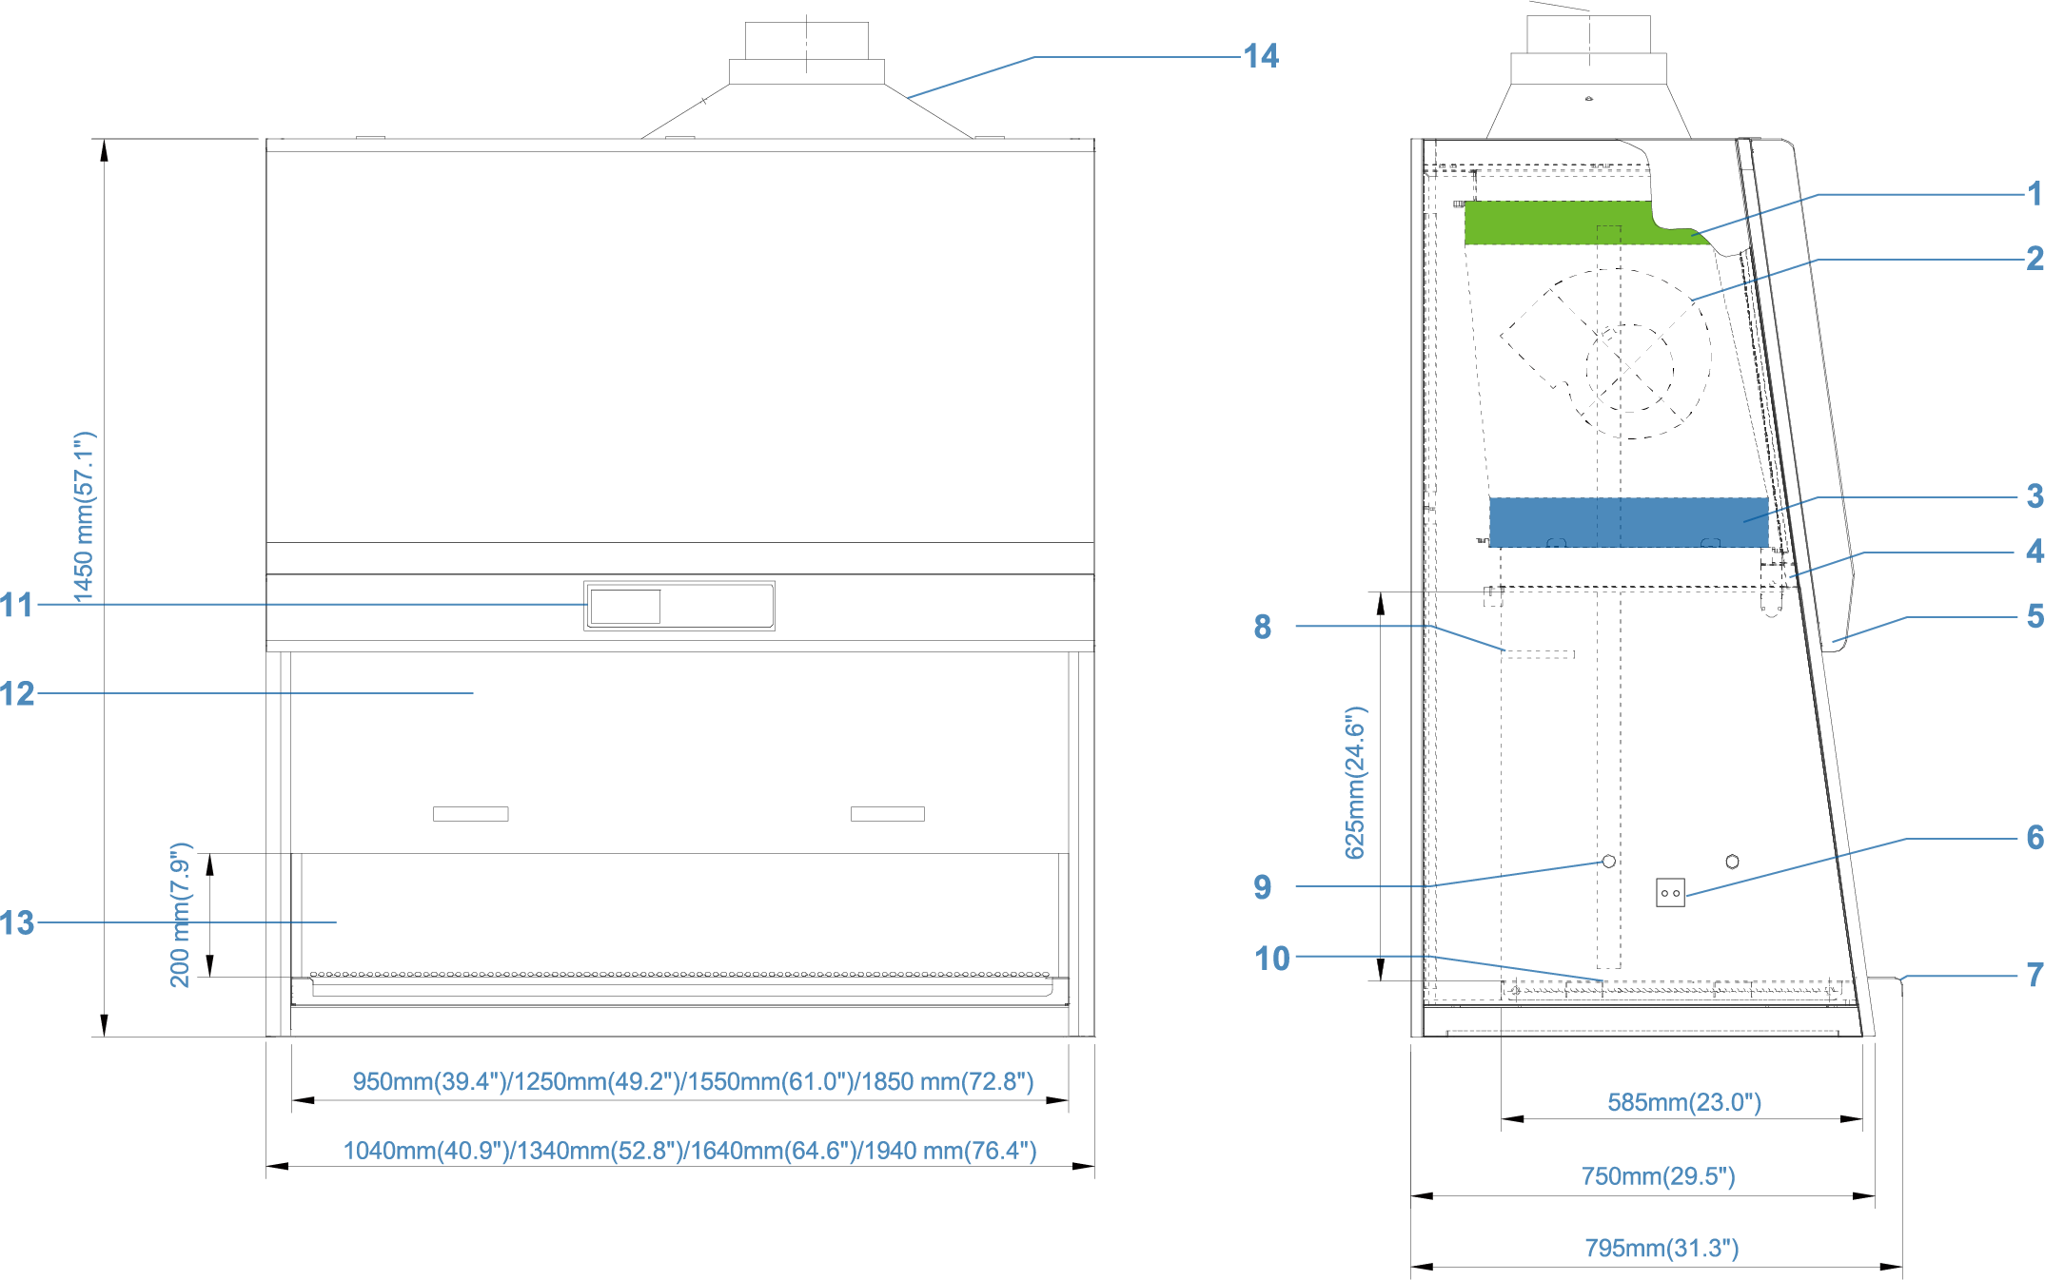
Optional Exhaust Collar Positions for Thimble-Ducting for HFsafe LC Models

HFsafe LC Biological Safety Cabinet Technical Specification

1.Exhaust filter
2. Blower
3. Downflow filter
4. Standard UV light
5. Fluorescent lighter
6. Universal electical outlet
(2 single outlets in work zone）
7. Stainless steel armrest
8. Downflow sensor
9. Gas /vacuum/water service fixture
10. Stainless steel single-piece work tray
11. Micro processor control system
12. Manual sliding sash
13. Single piece stainless steel back wall and side wall
14. Thimble exhaust collar(optional)
Model | HFsafe-900LC | HFsafe-1200LC | HFsafe-1500LC | HFsafe-1800LC
Nominal Size | 0.9 meters(3) | 1.2 meters(4) | 1.5 meters(5) | 1.8 meters(6)
External Dimensions with Base Stand | 1023×771×2255mm | 1323×771×2255mm | 1623×771×2255mm | 1923×771×2255mm
(W×D×H) | 40.3×30.4,×88.8 | 52.1×30.4'×88.8 | 63.90"×30.4,,×88.8 | 75.7×30.4×88.8
Internal Work Area, Dimensions | 900×600×678mm | 1200×600×678mm | 1500×600×678mm | 1800×600×678mm
(W×D×H) | 35.4,×23.6,×26.7 | 47.2,×23.6,×26.7 | 59.1,×23.6×26.7 | 70.9×23.6×26.7
Internal Work Area, Space | 0.54m²(5.8 sq.ft) | 0.72m²(7.8 sq.ft) | 0.9m²(9.7 sq.ft) | 1.08m²(11.6 sq.ft)
Average Airflow Velocity *
Inflow | 0.53m∕s(104.3fpm) | 0.53m∕s(104.3fpm) | 0.53m∕s(104.3fpm) | 0.53m∕s(104.3fpm)
Downflow | 0.35m∕s(68.9fpm) | 0.35m∕s(68.9fpm) | 0.35m∕s(68.9fpm) | 0.35m∕s(68.9fpm)
Airflow Volume
Inflow | 363m³∕h(213cfm) | 477m³∕h(281cfm) | 592m³∕h(348cfm) | 706m³∕h(416cfm)
Downflow | 658m³∕h(377cfm) | 866m³∕h(510cfm) | 1075m³∕h(633cfm) | 1282m³∕h(755cfm)
Exhaust | 363m³∕h(213cfm) | 477m³∕h(281cfm) | 592m³∕h(348cfm) | 706m³∕h(416cfm)
ULPA Filter Typical Efficiency
Downflow | Filters provide 99.9995% typical efficiency for particle size of 0.1 to 0.2 microns
Exhaust | Filters provide 99.9995% typical efficiency for particle size of 0.1 to 0.2 microns
Biosafety Protection Test
Personnel Protection Test | Kl-Discus ∞ntainment and microbiological testing is performed
Product Protection Test 1~8×10⁶ | ≤5CFU | ≤5CFU | ≤5CFU | ≤5CFU
Cross-∞ntamination Test 1~8×10⁶ ≤2CFU |  | ≤2CFU | ≤2CFU | ≤2CFU
Sound Emission (Typical)
NSF/ANSI 49 | <60dBA | <62dBA | <62dBA | <65dBA
EN 12469 | <57dBA | <59dBA | <60dBA | <62dBA
Fluorescent Light Intensity | 800~1200 Lux (74~112 foot candles)
Excellent light distribution | Yes | Yes | Yes | Yes
RMS | ≤2.3μm | ≤2.3μm | ≤2.3μm | ≤2.3μm
Cabinet Construction
Main Body | 1.2mm(0.05") steel with white oven-baked epoxy-polyester
Work Zone | 1.5mm(0.06) stainless steel, type 304
Side Walls | 1.5mm(0.06) stainless steel, type 304
Electrical sliding windows Option | Yes | Yes | Yes | Yes
Window material | Hardened/laminated safety glass
Electrical
Cabinet Full Load Amp(FLA) | 2A | 2A | 4A | 4A
Fuses | 10A | 10A | 10A | 10A
Cabinet Nominal Power | 361W | 452W | 813W | 850W
Optional Outlets FLA | 5A | 5A | 5A | 5A
Total Cabinet FI_A | 7A | 7A | 9A | 9A
Power Supply*
220V∕50Hz | Yes | Yes | Yes | Yes
220V∕60Hz | Yes | Yes | Yes | Yes
110V∕60Hz | Yes | Yes | N/A | N/A
Net Weight
Manual Type | 120kg(264lbs) | 225kg(496lbs) | 280kg(617lbs) | 320kg(705lbs)
Shipping Weight
Manual Type | 175kg(386lbs) | 295kg(650lbs) | 350kg(772lbs) | 390kg(860lbs)
Shipping Dimensions Maximum | 1125×945×1717mm | 1425×945×1717mm | 1725×945×1717mm | 2026×945×1717mm
(W×D×H) | 46.3×37.2×67.3 | 56×37.2×67.3 | 67.9×37.2,×67.3 | 79×37.2,×67.3
Shipping Volume, Maximum | 1.81m³(63.9cu.ft.) | 2.30m³(81.2cu.ft.) | 2.79m³(98.5cu.ft.) | 3.27m³(115.5cu.ft.)
* Please ntact us for more optional power supply information

General Specifications, HFsafe LC Biological Safety Cabinets (Class II Type A2)
* Please ntact us for more optional power supply information
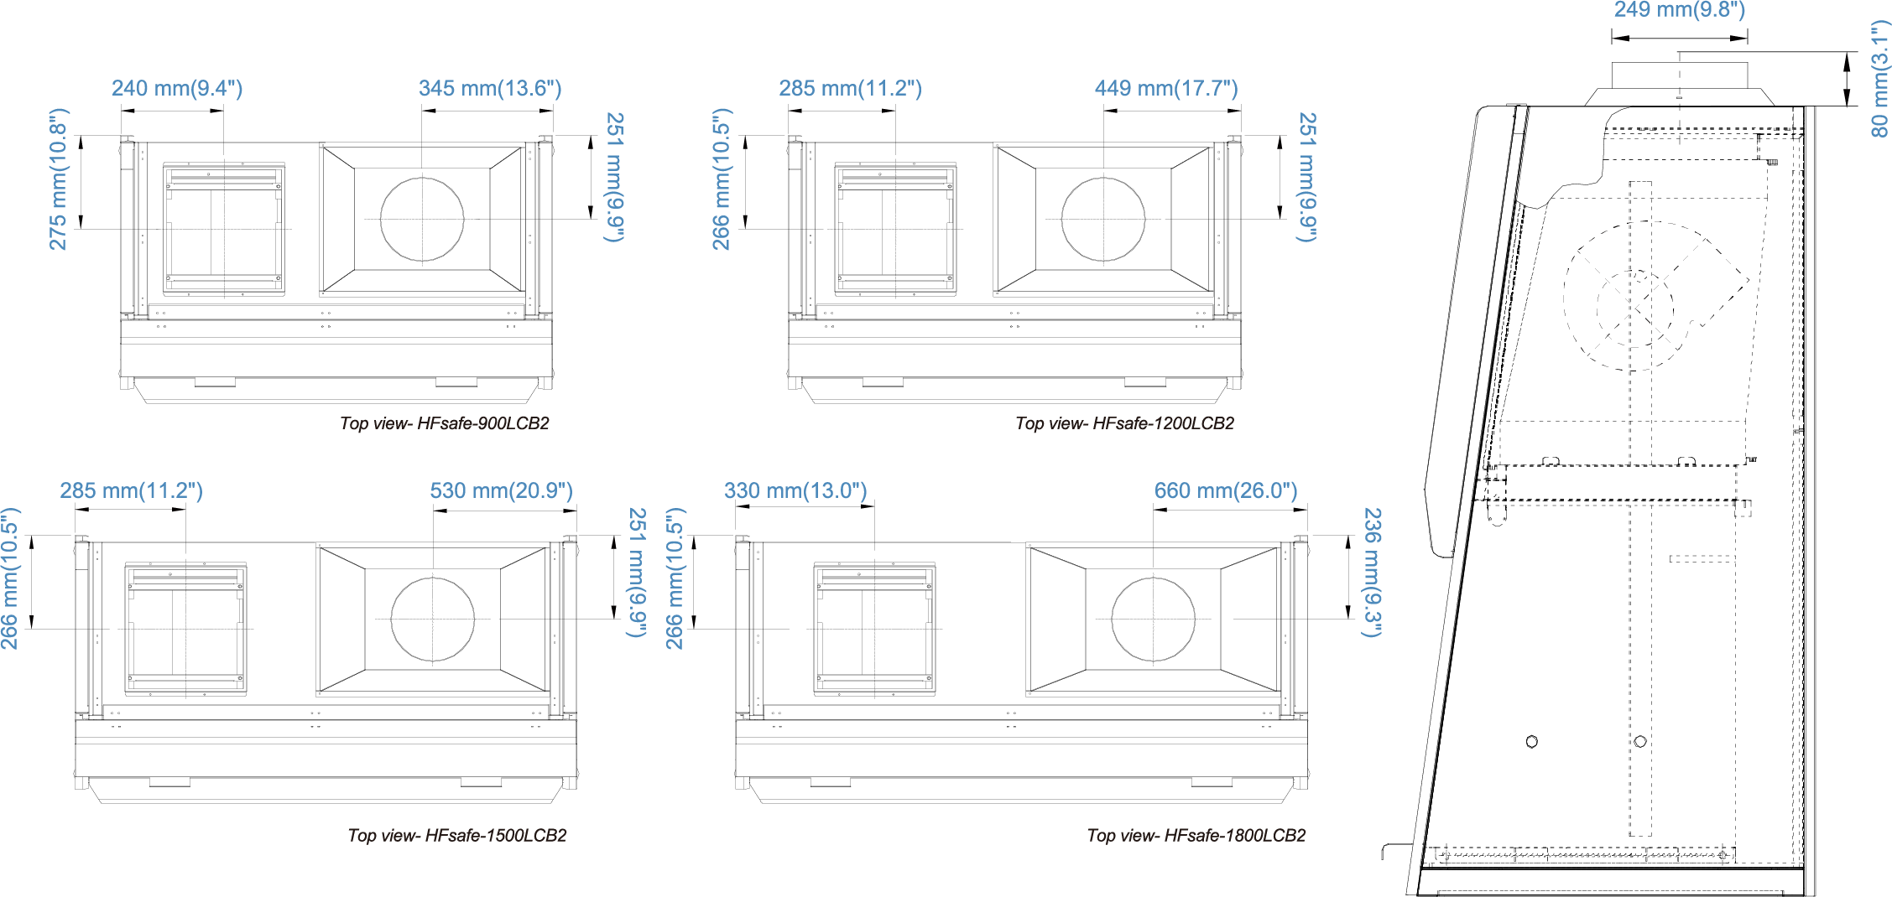
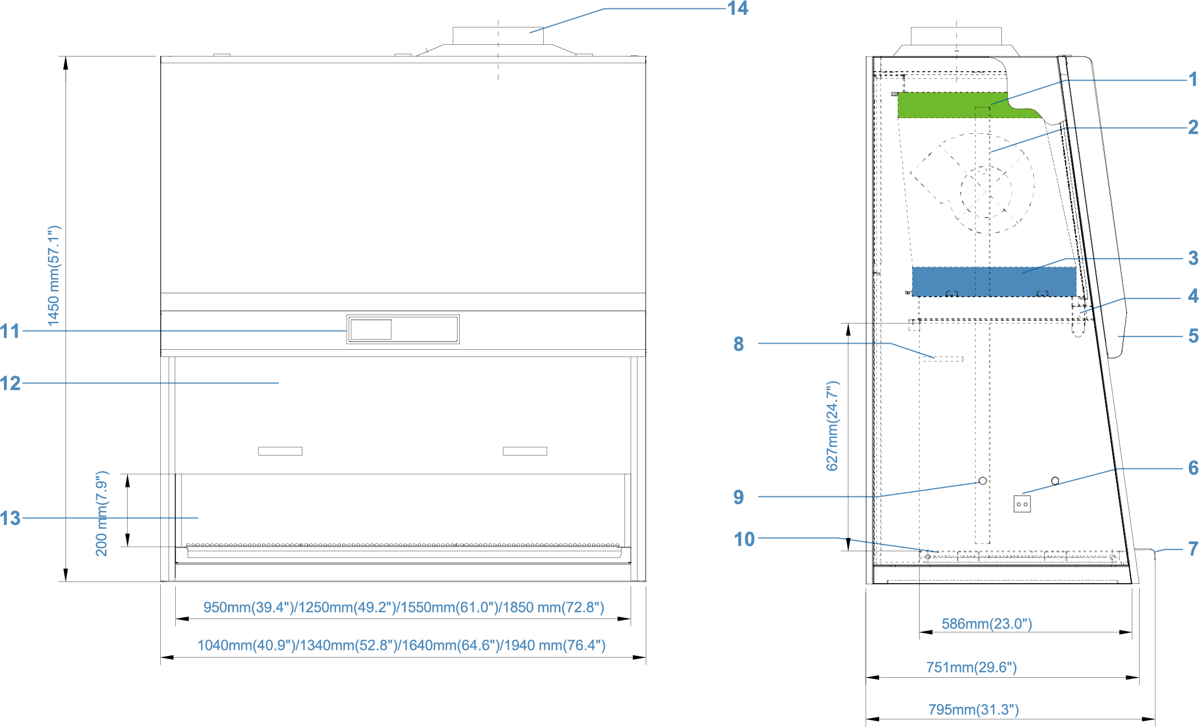
Standard Exhaust Collar Positions for Thimble-Ducting for HFsafe LCB2 ModelsModels

6. Universal electical outlet
(2 single outlets in work zone)
7. Stainless steel armrest
8. Downflow sensor
9. Gas /vacuum/water service fixture
10.Stainless steel single-piece work tray
11. Micro processor control system
12. Manual sliding sash
13. Single piece stainless steel back wall and side wall
14. Thimble exhaust collar

1.Exhaust filter
2. Blower
3. Downflow filter
4. Standard UV light
5. Fluorescent light
HFsafe LCB2 Biological Safety Cabinet Technical Specification

Model | HFsafe-900LCB2 | HFsafe-1200LCB2 | HFsafe-1500LCB2 | HFsafe-1800LCB2
Nominal Size | 0.9 meters(3) | 1.2 meters(4) | 1.5 meters(5) | 1.8 meters(6)
External Dimensions with Base Stand | 1040×710×2130mm | 1340×710×2130mm | 1640×710×2130mm | 1940×710×2130mm
(W×D×H) | 40.9×30.0×83.9 | 52.8×30.0×83.9 | 64.6×30.083.9 | 76.4×30.0×83.9
Internal Work Area, Dimensions | 950×575×625mm | 1250×575×625mm | 1550×575×625mm | 1850×575×625mm
(W×D×H) | 37.4×22.6,×24.6 | 49.2×22.6×24.6 | 61.0×22.6×24.6 | 72.8×22.6×24.6
Internal Work Area, Space | 0.54m²(5.8 sq.ft) | 0.72m²(7.8 sq.ft) | 0.9m²(9.7 sq.ft) | 1.06m²(11.4 sq.ft)
Average Airflow Velocity *
Inflow | 0.53m∕s(104.3fpm) | 0.53m∕s(104.3fpm) | 0.53m∕s(104.3fpm) | 0.53m∕s(104.3fpm)
Downflow | 0.30m∕s(59.1fpm) | 0.30m∕s(59.1fpm) | 0.30m∕s(59.1fpm) | 0.30m∕s(59.1fpm)
Airflow Volume
Inflow | 363m³∕h(214cfm) | 477m³∕h(281cfm) | 592m³∕h(348cfm) | 706m³∕h(416cfm)
Exhaust | 927m³∕h(546cfm) | 1220m³∕h(718cfm) | 1515m³∕h(892cfm) | 1805m³∕h(1062cfm)
Filter Typical Efficiency
Downflow | ULPA filters provide 99.9995% typical efficiency for particle size of 0.1 to 0.2 microns
Exhaust | HEPA filters provide 99.97% typical efficiency for particle size of 0.3 microns
Biosafety Protection Test
Personnel Protection Test | Kl-Discus ∞infotainment and microbiological testing is performed
Product Protection Test 1~8×10⁶ | ≤5CFU | ≤5CFU | ≤5CFU | ≤5CFU
Cross-∞insemination Test 1~8×10⁶ ≤2CFU |  | ≤2CFU | ≤2CFU | ≤2CFU
Sound Emission (Typical)
NSF/ANSI 49 | <60dBA | <62dBA | <62dBA | <65dBA
EN 12469 | <57dBA | <59dBA | <60dBA | <62dBA
Fluorescent Light Intensity
Excellent light distribution | Yes | Yes | Yes | Yes
RMS | ≤3μm | ≤3μm | ≤3μm | ≤3μm
Cabinet Construction
Main Body | 1.2mm(0.05") steel with white oven-baked epoxy-polyester
Work Zone | 1.5mm(0.06) stainless steel, type 304
Side Walls | 1.5mm(0.06) stainless steel, type 304
Electrical sliding windows Option | Yes | Yes | Yes | Yes
Window material | Hardened/laminated safely glass
Electrical
Cabinet Full Load Amp(FLA) | 4A | 4A | 5A | 5A
Fuses | 10A | 10A | 10A | 10A
Cabinet Nominal Power | 850W | 855W | 1200W | 1200W
Optional Outlets FLA | 5A | 5A | 5A | 5A
Total Cabinet FLA | 9A | 9A | 10A | 10A
Power Supply*
220V∕50Hz | Yes | Yes | Yes | Yes
220V∕60Hz | Yes | Yes | Yes | Yes
Net Weight
Manual Type | 210kg(463lbs) | 250kg(551lbs) | 295kg(650lbs) | 340kg(750lbs)
Shipping Weight
Manual Type | 260kg(573lbs) | 310kg(683lbs) | 365kg(804lbs) | 420kg(926lbs)
Shipping Dimensions Maximum | 1125×945×1710mm | 1425×945×1710mm | 1725×945×1710mm | 2026×945×1710mm
(W×D×H) | 44.3×37.2×67.3 | 56.T×37.2×67.3 | 67.9×37.2×67.3 | 79.8×37.2×67.3
Shipping Volume, Maximum | 1.81m³(64cu.ft.) | 2.30m³(81cu.ft.) | 2.79m³(99cu.ft.) | 3.27m³(115cu.ft.)
General Specifications, HFsafe LCB2 Biological Safety Cabinets (Class II Type B2)
* Please intact us for more optional power supply information

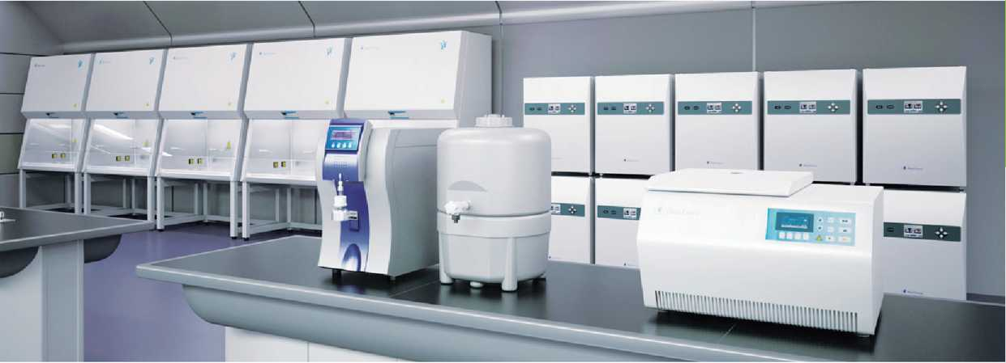
Biosafety Cabinet
Heal Force brand stands for the highest standards of safety, ergonomics and performance. Taking advantage of a heritage from over 25 years experience, Heal Force offers safety features, options and accessories beyond the standard requirements, to fulfill virtually all needs. Thousands of units installed in laboratories in more than 100 Countries
Centrifuge
Neofuge, the name that defines quality centrifuges from Heal Force. Offering bench-top high speed models with or without refrigeration for today¹ s discerning laboratory technicians. Neofuge series provide excellent centrifugal effect and maximum application versatility.
CO_{2/}Tri-Gas Incubator
Heal Force Smart Cell incubator provides you wiiħ unsurpassed natural simulation to ensure optimum growth ∞nditions for you culture at all time. Thafs why it becomes the first choice of researchers in fields of application including tissue engineering, in vitro fertilization, neuroscience, cancer research and other mammalian cell researches.
Water Purification
Well-proved Heal Force water purification system offers ideal and comprehensive solution for a choice of water qualities that range from primary for simple routine washing and rinsing, through to ultra-high grade for the most critical science and analytical applications.
Thermal Cycler
Since PCR is central for molecular biology research, you need flexible solutions that can help you achieve PCR success for virtually any application. Heal Force has been developing new cycling platforms from economical option to advanced series to empower your search. These instruments are renowned for their reliability, accuracy, and user-friendly interfaces.

Heal Force Bio-Meditech Holdings Group

Heal Force International Trading（shanghai）Co.Ltd
6788 songze Road，Qinpu District，shanghai201706，P.R.China
Tel： +86 21 62728646 E-mail：export@healforce.com Fax： +86 21 62710529
Website： www.healforce.com
Information is subject to change and/or updating without notice. Copyright © 2015 Heal Force. All Rights Reserved.

Heal Force Laboratory Equipment

Heal Force specialises in the design, development, manufacture and sales of laboratory equipments in the fields of Biosafety protection, Centrifugation, Cell culture, Water purification & Gene amplification.

